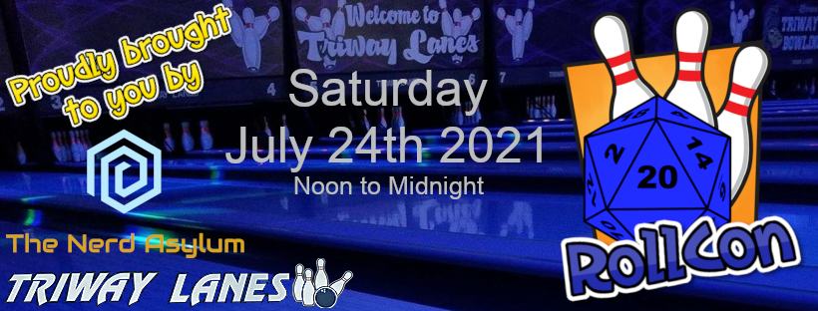

Vendor Sign-Up

- 8 ft. x 8 ft. Retail Space – $20 for the first space, $10 each additional space. Tables available upon request.

- Wi-Fi will be available. Electric hook-ups are limited and on a first-come-first-serve basis. Please indicate on the application if required.

- Vendors are responsible for decorating their space. Set up will be available beginning at 9:00 AM and must be completed by noon.

Vendor Name: ________________________________________________

Type of items for sale: __________________________________________
_____________________________________________________________

Preferred Contact Email: _______________________ Phone: ___________

Electrical Hook-up requested: Yes No

Please email application to matt.brown@thenerdasylum.com
The deadline to submit applications is June 1st, 2021
Approved applications will be invoiced by email

